4.7 NOTES – Writing Quadratic Equations Given a Point and the Vertex

Find a quadratic equation in the form y = a(x – h)² + k given the vertex & a point. Show all work.

- Vertex (-5, 2); contains (3, 18) ____________________
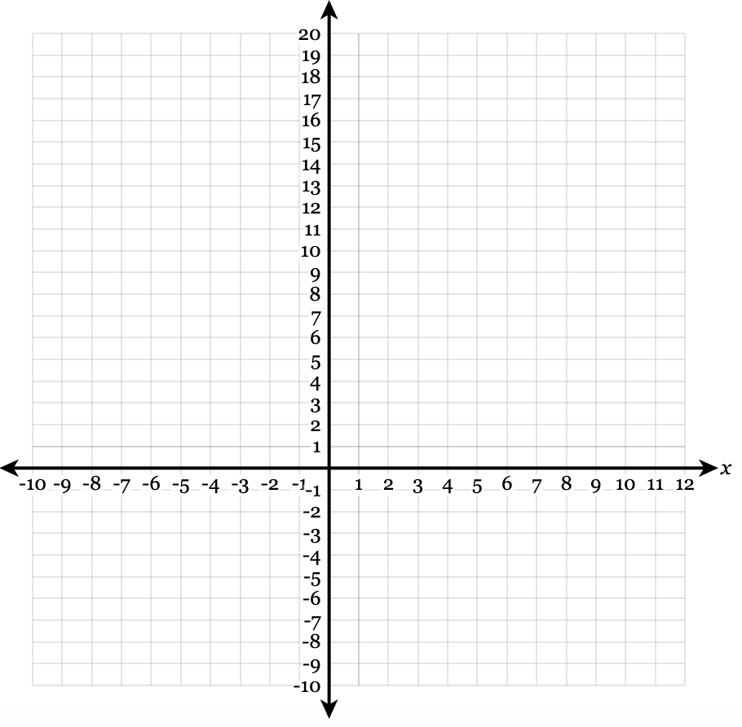

- Vertex (3, 0); contains (5, 0) ____________________

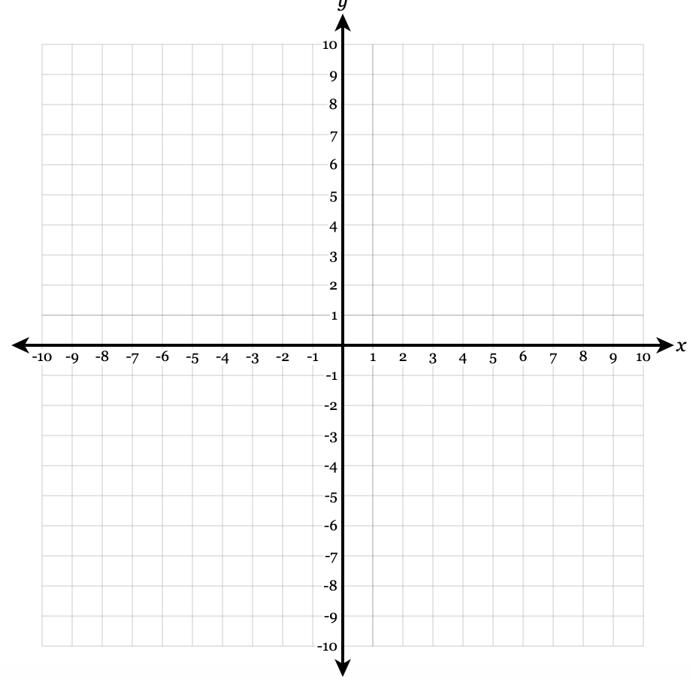

- Vertex (2, 6); y-intercept is 2 ____________________



- Vertex (-1, -8); one x-intercept is -3 ____________________



- Vertex (-2, -8); contains the origin ____________________



